**Faculty Profile**

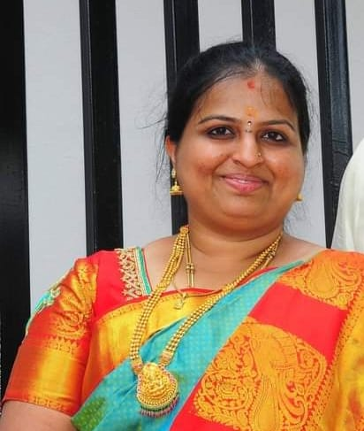

**Mrs. DIVYA SHREE D J**

**Dept. of Computer Science**

**Assistant Professor**

|  |  |  |
| --- | --- | --- |
| **Qualification** | **Specialization** | **Institution/University** |
| MSc | Computer Science | JSS College of Arts,  Commerce & Science,  Mysuru |
| Teaching Experience – 7Years | | |

**Seminars/Conferences/Symposium/Workshops**

|  |  |  |  |  |  |
| --- | --- | --- | --- | --- | --- |
| **Sl.No** |  | **Name of the**  **Conference /Seminar**  **/Symposium/Workshop** | **Type of**  **Program** | **Role** | **Venue/place** |
| 1 |  | LaTex workshop | Workshop | Participant | JSS College of Arts,  Commerce &  Science, Mysuru |
| 2 |  | Choice based  Credit system(cbcs) | Seminar | Participant | JSS College of Arts,  Commerce &  Science, Mysuru |
| 3 |  | Faculty Induction Programme | Workshop | Participant | JSS College of Arts,  Commerce &  Science, Mysuru |