Faculty Template

Name :Syeda Tahreem
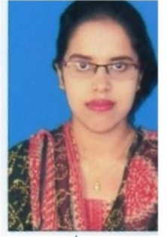
Designation :Assistant professor
Email – Id :Syedatahreem1729@gmail.com
Qualification:M.Sc, KSET
No. of Publications : -

Know More
Educational Qualification :
Sl.No | Qualification/Programme | Institution / University | Year of Passed Out /Period
1. | M.Sc | University of Mysore | 2021
2. | KSET | University of Mysore | 2021

Work Experience:
Sl.No | Institution Name / Employer Name | Designation / Department | Period
1. | JSS CACS | Assistant Professor PG Zoology | 2022 Feb till date

