FACULTY PROFILE

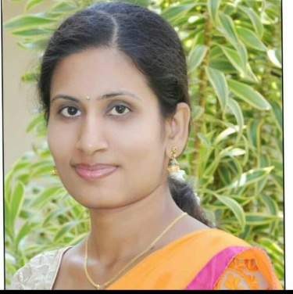

**Smt. Rakshitha R**

**M.Sc, B.ed**

**ASSISTANT PROFESSOR**

# Qualification:

|  |  |  |  |
| --- | --- | --- | --- |
| **Degree** | **University/Institution** | **Year** | **Specialization** |
| MSc | JSS College of Art’s Commerce and Science | 2018 | General Chemistry |
| B.Ed | Subramanya college of education banglore university | 2015 | physics & Mathematics |

**Seminars/Conferences/Workshop/ symposia attended.**

|  |  |  |  |
| --- | --- | --- | --- |
| **Name of the**  **Teacher** | **Title of the Event** | **Organizer** | **Date and Year** |
| **Rakshitha R** | Two day extension lecture programme in chemical biology | Centre for continuing education Indian institute of science bengalure | 27 to 28 december 2018 |
|  | National level online sports quize | Hindustan first grade college ,mysuru | 27 june 2020 |
|  | A step towards enhancement of quality in higher education | IQAC | 7th july 2020 |
|  | E-QUIZE on chemical science | Bharathi college , bharathinagar, mandya | 15 july 2020 |
|  | Application of chemistry in daily life | Department of chemistry from jss college nanjangudu | 16 july 2020 |
|  | Online quize on chemistry | CDC kagazhnagar | 17 july 2020 |
|  | The role of green chemistry in controlling environmental and ocean pollution | Gangasheel mahavidyalaya | 17 july 2020 |
|  | National level online e-quize on general chemistry | Govt degree college mancherial | 18 july 2020 |
|  | Covid-19 and Indian economy: issues and challenges | JSSCACS,Mysore | 28 july 2020 |
|  | “Chemistry behind biocomposting and biogasification” A sustainable way of managing organic waste | JSS college saraswathipuram mysuru | 10 august 2020 |
|  | Orientation and retraining programme for teachers | JSSCACS,Mysore | 14 january 2022 |
|  | day state level orientation and retraining programme for teachers | JSSCACS | 28 february 2022 |