FACULTY PROFILE

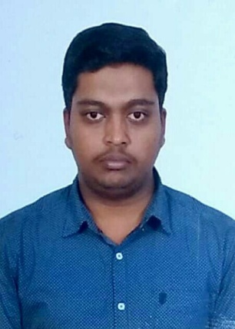

**Mr. Karthik G**

**M.Sc, KSET, (Ph.D)**

**ASSISTANT PROFESSOR**

# Qualification:

|  |  |  |  |
| --- | --- | --- | --- |
| **Degree** | **University/Institution** | **Year** | **Specialization** |
| MSc | JSS College of Art’s Commerce and Science | 2018 | General Chemistry |
| PhD | University of Mysore | pursuing |  |

**Seminars/Conferences/Workshop/ symposia attended.**

|  |  |  |  |
| --- | --- | --- | --- |
| **Name of the**  **Teacher** | **Title of the Event** | **Organizer** | **Date and Year** |
| **Karthik G** | Advanced analytical techniques for polymer characterization | Jss science & technology university | 29 january 2018 |
|  | Industry-academia interaction seminar | JSSCACS,Mysore | 17 march 2018 |
|  | Applied chemistry: A catalyst for scientific transformations | SGT university | 23 to 28 august 2021 |
|  | Two day international E-conference on drug discovery and material science | JSSCACS,Mysore | 15 to 16 september 2021 |
|  | International conference on multidisciplinary aspects of environment and sustainable development | Department of zoology at raj rishi govt college | 15 to 18 december |
|  | Orientation and retraining programme for teachers | JSSCACS,Mysore | 14 january 2022 |
|  | National education policy | Seshadripuram degree college | 25 january 2022 |
|  | UGC sponsored one day state level orientation and retraining programme for teachers | JSSCACS | 14 january 2022 |
|  | day state level orientation and retraining programme for teachers | JSSCACS | 28 february 2022 |
|  | UGC sponsored one day seminar on INTELLECTUAL PROPERTY RIGHTS | JSSCACS | 3 march 2022 |