Faculty Profile

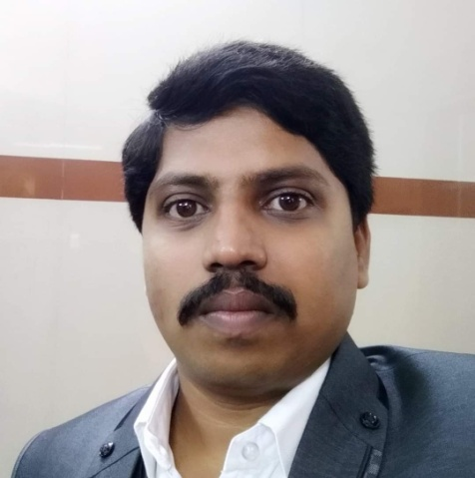

**Mr. Nandish M**

**MCA**

**Assistant Professor**

**Qualification:**

|  |  |  |
| --- | --- | --- |
| **Programme** | **Specialization** | **Institution/University** |
| MCA | Computer Application | VTU |
| **Total Experience: 10 years and above** | | |

|  |  |  |  |  |
| --- | --- | --- | --- | --- |
| **Seminars/Conferences/Symposium/Workshops** | | | | |
| **Sl. No** | **Name of the**  **Conference**  **/Seminar**  **/Symposium/Workshop** | **Type of**  **Program** | **Role** | **Venue/ Place** |
| 1. | Promotion Of Research in Colleges | Workshop | Participant | JSS College of Arts, Commerce & Science,  Mysuru |
| 2. | Teaching and Learning in the 21st Century- Student Centric  Approach | Orientation  Programme | Participant | JSS College of Arts, Commerce & Science, Mysuru |
| 3. | Core Competency in Computing | Seminar | Participant | JSS College of Arts, Commerce & Science,  Mysuru |
| 4. | Choice Based Credit System(CBCS) | Seminar | Participant | JSS College of Arts,  Commerce & Science, Mysuru |
| 5. | LaTex workshop | Seminar | Participant | JSS College of Arts, Commerce & Science,  Mysuru |
| 6. | Faculty Induction Programme | Workshop | Participant | JSS College of Arts,  Commerce & Science, Mysuru |
| 7. | Teacher’s Capacity Building | Workshop | Participant | JSS College of Arts, Commerce & Science,  Mysuru |
| 8. | UGC Sponsored Four Days Frontier Series | Seminar | Participant | JSS College of Arts,  Commerce & Science, Mysuru |
| 9. | Emerging Trends in Internet of Things | Workshop | Participant | JSS College of Arts, Commerce & Science,  Mysuru |
| 11. | UGC Sponsored One Day State Level “Orientation and Retraining Programme for Teachers” | Workshop | Participant | JSS College of Arts, Commerce & Science,  Mysuru |
| 12. | “One Day State Level Orientation and Retraining Programme for Teachers” | Workshop | Participant | JSS College of Arts, Commerce & Science,  Mysuru |

1. Member of BOE – JSSCACS, Mysuru, 2022-2023.

2. Member of BOS – JSSCACS, Mysuru, 2016-2021.