Faculty Profile

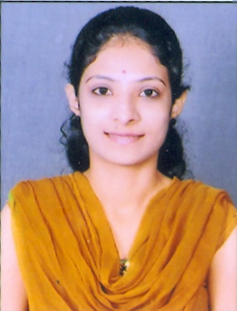

Ms. Anusha
ASSISTANT PROFESSOR
Qualification

Programme | Specialization | Institution/University
MSc | Computer science | Mysore University

Seminars/Conferences/Symposium/Workshops

Sl. No | Name of the Conference /Seminar /Symposium/Workshop | Type of Program | Role | Venue/place | Date
1 | Kannada dalli Vignyana Samellana | Seminar | Participant | J.S.S College of Arts, Commerce and Science, Ooty Road, Mysuru | 23 and 24 November 2017
2 | Quality of Higher Education, importance of Research and ICT-Enabled Teaching | Orientation Programme | Participant | J.S.S College of Arts, Commerce and Science, Ooty Road, Mysuru | 30th November 2017
3

