Faculty Profile
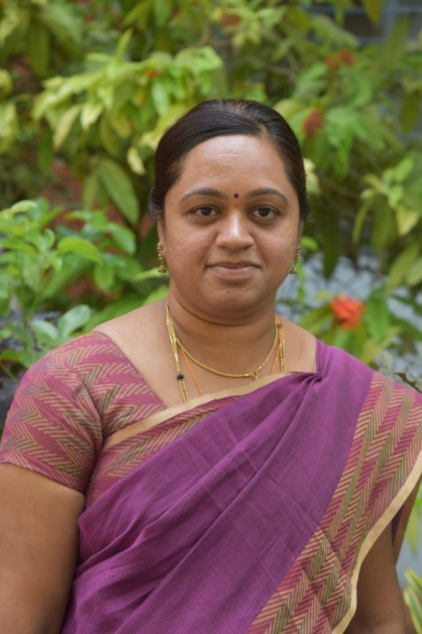

Dr. Shilpa N, M.Sc, M.Phil, Ph.D, KSET.

Assistant Professor

PG Department of Mathematics

QUALIFICATION

PROGRAMME | SPECIALIZATION | INSTITUTION/UNIVERSITY
M.Sc. | Mathematics | University of Mysore, Mysore
M. Phil. | Mathematics | Sri Venkateswara University, Tirupati
Ph.D | Complex function theory | University of Mysore, Mysore
KSET | Mathematics | -

EXPERIENCE

DESIGNATION | INSTITUTION | PERIOD
Lecturer | J.S.S P. U. College for women, Yelandur. | June 2004 to Mar 2007
Lecturer | J.S.S P. U College, J.P. Nagar, Mysuru. | Jan 2005 to Mar 2007
Project fellow,  UGC Major research project | Department of Mathematics, Yuvaraja’s College, University of Mysore, Mysuru. | Jan 2011 to Jan 2013
Assistant Professor | PG Department of Mathematics, J.S.S College of Arts Commerce and Science, Ooty Road, Mysuru. | Sep 2013 till date

ARTICLES IN JOURNALS

- Subclasses of analytic functions involving Salagean –Ruscheweyh operator, N Shilpa and S Latha, Analele Universitatii Oradea, Fasc. Mathematica, Tom XVIII, pp., 249 – 256, 2011.

- A note on Ruscheweyh type functions, N Shilpa and S Latha, Journal of Rajasthan Academy of Physical Sciences, Vol. 10, No. 1, pp., 53 – 62, 2011.

- Some results involving functions with negative coefficients and Al-Oboudi operator, N Shilpa and S Latha, Journal of Advanced Studies in Topology, Vol.3, No. 1, pp., 89-97, 2012.

- Some results on differential operator, N Shilpa and S Latha. Journal of advanced research in pure mathematics. Vol 4, Issue 3, pp.19-25, 2012.

- Subordination results for the functions involving differential operator, N Shilpa and S Latha. International Journal of Mathematical Sciences and Engineering Applications, Vol 6, No.II, pp.171-177, 2012.

- Coefficient inequalities for certain classes of Janowski- Sakaguchi type functions, N.Shilpa and S.Latha, International Journal of Pure and Applied Mathematics, Vol 81, No.5, 663-669. 2012.

- Some properties of subclasses of analytic functions with respect to N-symmetric points, N Shilpa and S Latha. International Journal of Mathematics and Computing System, Vol.3, No.2, pp.9-16, July-Dec 2012.

- A note on convolution properties, N Shilpa, L Dileep and S Latha, Proceedings of National Seminar on Current Research and Developments in Mathematics and Computing (CRDMC-2012). Narosa, pp.37-42. 2012.

- On subclasses of analytic functions associated with hypergeometric functions, N Shilpa and S Latha, Journal of advanced research in pure Mathematics, Vol.5, Issue 4, pp.17-26, 2013.

- On neighborhoods of subclasses of analytic functions defined using differential operator, N Shilpa and S Latha, International Journal of Mathematics Trends and Technology, Vol 24, Issue1, pp.54-63, 2015.

- Subordination results for Sakaguchi type functions, N Shilpa and S Latha, Global Journal for Research analysis, Volume 5, Issue 6, pp.119-123, 2016.

- Some results on generalized Sakaguchi type functions, N Shilpa and S Latha, International Journal of Mathematical Archive, Vol. 7(9), pp.143-146, 2016.

- Some results on functions associated with k-symmetric points, N Shilpa and S Latha, International Journal of Emerging Technology and Research, Vol. 3, Issue 5, pp.54-56, 2016.

- On subclasses of analytic functions associated with λ-spirallike generalized Sakaguchi type functions, N Shilpa and S Latha, Asia Pacific Journal of Mathematics, Vol. 4, No. 2, pp. 137-143, 2017.

- On generalized differential and integral operators, N Shilpa and S Latha, International Journal of Pure and Applied Mathematics, Vol. 117, No.20, pp.179-186, 2017.

- Some results on λ-spirallike generalized Sakaguchi type functions, N Shilpa and S Latha, Palestine Journal of Mathematics, Vol. 7(1), pp. 289-293, 2018.

- Certain subclasses of analytic functions involving generalized differential and integral operators, N Shilpa and S Latha, Mathematical inverse problems, Vol. 5(1), pp. 46-55, 2018.

- On generalized q- Sakaguchi type functions, N Shilpa and S Latha, International Journal of Mathematics and its Applications, 7(1), pp.155-160, 2019.

- Convolution conditions for sakaguchi Janowski type functions, N Shilpa, Hamid shamsan and S Latha, Journal of applied science and computations, Vol. VI, (IV), 2019.

- Some properties of subclasses of analytic functions with negative coefficients, N Shilpa, South East Asian Journal of Mathematics and Mathematical Sciences, vol. 15, No. 3, pp. 41-52, 2019.

- Convolution conditions and generalized Janowski Sakaguchi type functions, N. Shilpa, Advances in Mathematics: Scientific Journal 9, No. 8, pp. 5649-5654, 2020.

CONFERENCE / WORKSHOP/ SEMINAR ATTENDED

SL. NO. | TITLE OF THE CONFERENCE | PERIOD | ORGANIZERS
 | UGC Sponsored National Conference on Analysis and Applications | 15 to 17 March, 2011 | Department of Mathematics,  Karnatak University, Dharwad
 | UGC sponsored National Conference on Applications of Mathematics and Statistics | 25 to 26 March, 2011. | Department of Mathematics, Yuvaraja’s College, Mysuru. (Organizing Committee member)
 | International Conference on Special Functions | 28 to 30 July, 2011 | Department of Mathematics  And Statistics, J.N. Vyas university, Jodhpur, Rajasthan.
 | National Conference on Functional analysis and its applications | 17 to18 Feb, 2012 | Department of Mathematics  P.E.S College, Mandya.
 | National Conference on Graph Theory and Number Theory | 21 to 22 Mar, 2012 | Department of studies in Mathematics, University of Mysore, Mysuru.
 | One day state level workshop on Algebra and Graph Theory | 29th Mar, 2012 | Maharani’s science college for women, J.L.B Road, Mysuru.
 | National Seminar on Current Research and Developments in Mathematics and Computing | 03 to 04  Oct, 2012 | Aliah university,  Kolkata.
 | International Conference on the works of Srinivasa Ramanujan and related topics | 12 to 14 Dec, 2012 | Department of studies in Mathematics,  University of Mysore,  Mysuru.
 | One day National conference on ‘Recent advances in Mathematics’ | 24th Jan, 2014 | Department of Mathematics,  JSS College of Arts, Commerce and Science, Ooty Road, Mysuru. (Organizing Committee member)
 | KSTA Regional Conference on “Science and Technology for Education and Health Care” | 21 to 22  Feb, 2014. | JSS College of Arts, Commerce and Science, Ooty Road, Mysuru.
 | International Conference on  Mathematics - Yesterday and Today-2014 | 26 to 27 Dec, 2014 | Department of Mathematics,  JSS College of Arts, Commerce and Science, Ooty Road, Mysuru. (Organizing Committee member)
 | Promotion of research in colleges | 14th March, 2015 | JSS College of Arts, Commerce and Science, Ooty Road, Mysuru.
 | One day Orientation Programme Teaching and Learning in the 21st century student centric Approch | 30th March, 2015 | JSS College of Arts, Commerce and Science, Ooty Road, Mysuru.
 | 103rd Indian Science Congress. | 3 to 7  Jan, 2016 | Indian Science Congress. University of Mysore, Mysuru.
 | National Seminar on Recent Advances in Mathematics and its Applications | 18 to 19  Feb, 2016 | Department of Mathematics,  JSS College of Arts, Commerce and Science, Ooty Road, Mysuru. (Organizing Committee member)
 | Two Day National Workshop on Number Theory | 26 to 27  Feb, 2016 | DOS in Mathematics, University of Mysore, Mysuru.
 | Two days work shop on “Research and publication” | 18 to 19 Mar, 2016. | IQAC Cell, JSS College for Women, Mysuru.
 | State level Science Exhibition on the theme  “Science and Village” | 20 to 22 Aug, 2016. | KSTA, JSS College of Arts, Commerce and Science, Ooty Road, Mysuru.
 | International conference on Mathematical impacts in Science and Technology | 17 to 18  Nov, 2017 | Bannari Amman Institute of Technology, Sathyamangala.
 | Science and Technology Seminar | 24 to 25 Nov, 2017 | KSTA, JSS College of Arts, Commerce and Science, Ooty Road, Mysuru.
 | UGC Sponsored one day orientation programme on quality of higher education, importance of research and ICT enabled teaching | 30 Nov, 2017 | IQAC, JSS College of Arts, Commerce and Science, Ooty Road, Mysuru.
 | National Conference on Geometric functions theory and its applications in honor of Dr. S Latha | 29 to 30 Jan, 2018 | Yuvaraja’s college, University of Mysore, Mysuru. (Organizing Committee member)
 | UGC sponsored one day Workshop on Capacity Building | 24th March, 2018 | JSS College of Arts, Commerce and Science, Ooty Road, Mysuru
 | UGC sponsored one day State level Workshop on Capacity Building for Teachers | 16th Feb, 2019 | JSS College of Arts, Commerce and Science, Ooty Road, Mysuru
 | UGC Sponsored Two day National Conference on Current trends in Mathematics | 21 to 22 Feb, 2019 | Department of Mathematics,  JSS College of Arts, Commerce and Science, Ooty Road, Mysuru. (Convener)
 | International conference on Number theory and Graph theory | 27 to 29 June, 2019 | DOS in Mathematics, University of Mysore, Mysuru
 | Teacher’s capacity building | 13 Feb 2020 | JSS College of Arts, Commerce and Science, Ooty Road, Mysuru
 | Four day Frontier Lecture series | 25 to 28 Feb 2020 | JSS College of Arts, Commerce and Science, Ooty Road, Mysuru
 | Recent advances in Pure and applied Mathematics, | 10 to 11 July 2020 | Dept. of Mathematics, Narajole Raj college, Paschim Medinipur.
 | Two Days International Webinar on Complex Analysis and Its Applications | 22 to 23 July 2020 | Department of Mathematics, K. L. E. Society’s G. I. Bagewadi College, Nipani
 | “The Moore Penrose Inverse, Singular Value Decompositions and their Applications, | 30 July 2020 | Department of Mathematics VVCE, Mysuru
 | One day National level webinar on Matrix and its applications to differential equations, | 8 Aug 2020 | AIMAN College, Tiruchinappalli
 | “Zerodivisor Graph of a Commutative Semi Group With 0” | 26 Aug 2020 | Department of Mathematics, Don Bosco Institute of Technology,  Bengaluru.
 | Two day International Web conference On Research Trends in Applied Science, Engineering and Technology. | 27 to 28 Aug 2020 | Department of Mathematics  Pasumpon Muthuramalinga Thevar College, Usilampatti.
 | International virtual conference on Bridging innovative trends in mathematics,Engineering and technology | 18 to 19 Dec 2020 | Department of Mathematics, bannari amman Institute of technology, Sathyamangala. Tamilnadu.
 | One day state level workshop on Research methodology for researchers and teachers | 13 Mar 2021 | JSSCACS, Ooty road, Mysuru
 | International conference on advances in Mathematics and Computer Science | 16 to 17 Apr 2021 | IMRF Institute of higher education, Vijayawada, Andra Pradesh
 | One day webinar on Best practices in online teaching | 16 June 2021 | JSSCACS, Ooty road, Mysuru
 | National webinar on Nurturing leadership | 1 July 2021 | JSS College for Women, Mysuru.
 | The significance of Intellectual property rights | 22 July 2021 | JSSCACS, Ooty road, Mysuru
 | Fluid mechanics and its industrial applications | 26 to 28 oct 2021 | Department of PG studies and research in Mathematics, kuvempu university

LIST OF PAPERS PRESENTED

Sl. No. | Date | Event | Place | Organizer | Title of the paper presented
1. | 15-03-2011 to  17-03-2011 | UGC Sponsored National Conference on Analysis and Applications | Dharwad | Department of Mathematics,  Karnatak University. | Some results involving functions with negative coefficients and Al-Oboudi operator
2. | 28-07-2011 to  30-07-2011 | International Conference on Special Functions | Jodpur, Rajasthan. | Department of Mathematics  and Statistics,  J.N.Vyas University. | Subclasses of analytic functions associated with hypergeometric functions
3  . | 03-10-2012  to  04-10-2012 | National Seminar on Current Research and Developments in  Mathematics and Computing | Kolkata. | Aliah university. | A note on convolution properties.
4. | 26-12-2014  to  27-12-2014 | International Conference on  Mathematics - Yesterday and Today-2014 | Mysuru. | Department of Mathematics,  JSS College, Ooty Road | Convolution conditions and Janowski- Sakaguchi type functions
5. | 17-11-2017  to  18-11-2017 | International conference on Mathematical impacts in Science and Technology | Sathyamangala | Department of Mathematics,  Bannari Amman Institute of Technology, Sathyamangala. | On Generalized Differential and Integral operators
6. | 27-09-2020  to  28-09-2020 | Two day International Web Conference on Research trends in applied Science, Engineering and Technology | Tamilnadu | Department of Mathematics,  Pasumpon Muthuramalinga Thevar College, Usilampatti | Fekete-Szego inequality for classes of analytic functions involving (p,q)-derivatives
7. | 18-12-2020  to  19-12-2020 | International virtual conference on Bridging innovative trends in mathematics, Engineering and technology | Tamilnadu | Department of mathematics, bannari amman Institute of technology, Sathyamangala. | Some results on subclasses of analytic functions involving (p,q) derivatives

OWN M.Phil/ Ph.D THESIS

Sl. No. | Title | Guide Name | Institution | Month Year | Status
1 | M.Phil: A study of complex function theory | Prof. S. Latha | Venkateshwara University, Tirupati | Apr 2009 | Awarded
2 | Ph.D: Recent interests in complex function theory | Prof. S. Latha | University of Mysore, Mysore | Jan 2014 | Awarded

